**Student:** Oleksandr Romanchenko

**ID:** 83459

**Chunk dataset. rankScore() and rawProbScore() functions.**

**Preparing data**

**Modelling**

**Decision Tree**

**GLM**

**RPART**

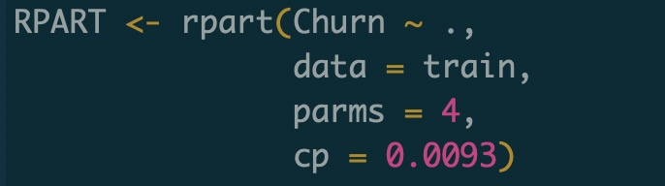

**Preparing data for creating 2 columns and sorting by them**

Next, performing wise-step selection

Setting ActiveDataSet variable. It's important for functions rankScore () and rawProbScore()

Adding new variable Score allows ranking creation.

Functions rankScore and rawProbScore are defined in package RcmdrPlugin.BCA

And sorting the data with sql query



And this is how data looks like after sorting

